**REV2_1.Modelo RF5_Indeg Apoio Levantamento diques cintura X All var**.

***Instrucciones modelo***: **test size = 0.2 ; rd_state = 46**

***Variables indep select to fit***:

variables = ['id', 'Indeg_IntimAmigos_'

, 'Indeg_RedeRisk_Cen','PC1_Distance_Pro',

    'Avg_Distancia_Dist_moranza','Degree_RedeTotFamil',

   '2_VarExp_Atri_Tabanca', 'OutDeg_RedeRisk_Cen']

***Model performance (scores):***

Mean Squared Error: 1.076

R^2 Score: 0.3412 (In Excel: R2 = 0.3995 ; y = 0.4118 X + 0.6018 )

**Model tot:**

Mean Squared Error (MSE): 0.3953

Root Mean Squared Error (RMSE): 0.6288

Mean Absolute Error (MAE): 0.3178

R^2 Score: 0.7465

Pearson Correlation: 0.8725

***Interactions***:

| **Interacción** | **Importancia** | **Dirección** |
| --- | --- | --- |
| 0 | (Degree_RedeTotFamil, OutDeg_RedeRisk_Cen) | 0.429567 | 0.062689 |
| 1 | (Area_bolanha, OutDeg_RedeRisk_Cen) | 0.373821 | 0.004963 |
| 2 | (PC1_Distance_Pro, OutDeg_RedeRisk_Cen) | 0.370396 | -0.000735 |
| 3 | (Indeg_IntimAmigos_, OutDeg_RedeRisk_Cen) | 0.370101 | -0.013838 |
| 4 | (Indeg_RedeRisk_Cen, OutDeg_RedeRisk_Cen) | 0.369421 | 0.063527 |
| 5 | (9_VarExp_Atri_IndMelhorTecnDiqCint, OutDeg_Re... | 0.363841 | -0.004219 |
| 6 | (2_VarExp_Atri_Tabanca, OutDeg_RedeRisk_Cen) | 0.359583 | 0.184396 |
| 7 | (Avg_Distancia_Dist_moranza, OutDeg_RedeRisk_Cen) | 0.300800 | -0.003407 |
| 8 | (Indeg_RedeRisk_Cen, Degree_RedeTotFamil) | 0.300796 | 0.070572 |
| 9 | (Degree_RedeTotFamil, Area_bolanha) | 0.247644 | 0.050677 |

***Key results****:*

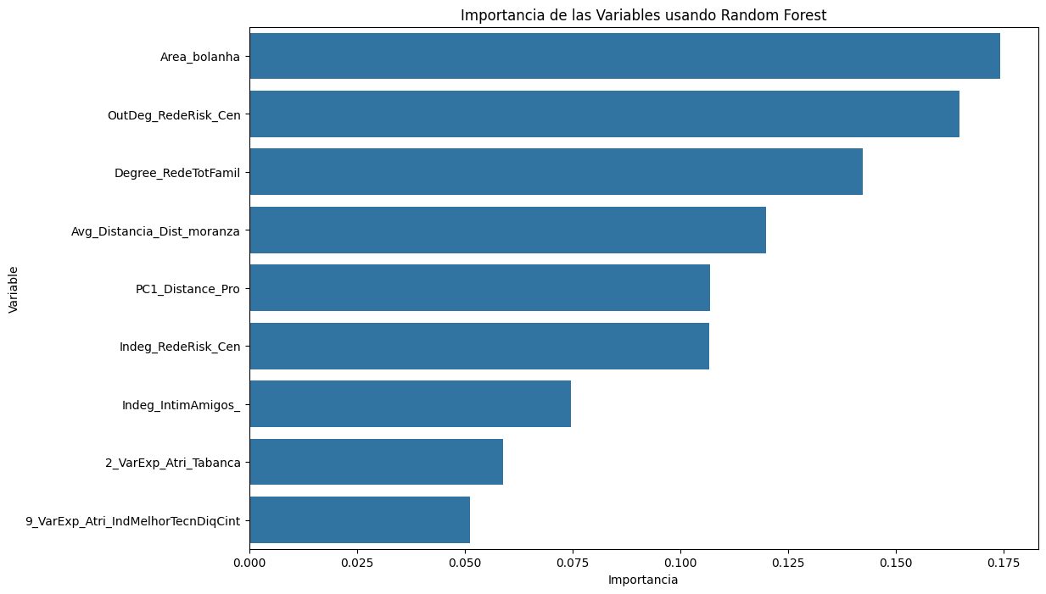

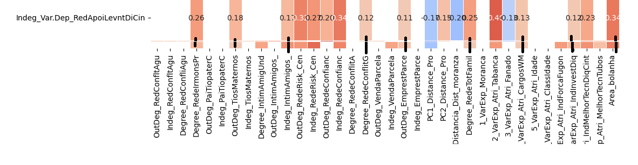

**REV 2.Modelo RF5_Outdeg Apoio Levantamento diques cintura X All var**.

***Instrucciones modelo***: **test size = 0.23 ; rd_st: 9**

***Variables indep select to fit***:

variables = [ 'id', 'Indeg_IntimAmigos_', 'Indeg_RedeRisk_Cen',

'PC1_Distance_Pro', 'Degree_RedeTotFamil', '8_VarExp_Atri_IndInvestDiq', 9_VarExp_Atri_IndMelhorTecnDiqCint','Area_bolanha','OutDeg_RedeRisk_Cen']

***Model performance (scores):***

Mean Squared Error: 0.7000

R^2 Score: 0.5880 (on excel: **R2= 0.605 ; Y = 0.5847 X + 0.2348**)

**Model tot:**

Mean Squared Error (MSE):0.2558

Root Mean Squared Error (RMSE):0.5058

Mean Absolute Error (MAE): 0.2248

R^2 Score: 0.8095

Pearson Correlation: 0.9059

***Interactions***:

| **Interacción** | **Importancia** | **Dirección** |
| --- | --- | --- |
| 0 | (Indeg_IntimAmigos_, 9_VarExp_Atri_IndMelhorTe... | 0.685101 | 0.141876 |
| 1 | (9_VarExp_Atri_IndMelhorTecnDiqCint, OutDeg_Re... | 0.597814 | 0.133051 |
| 2 | (9_VarExp_Atri_IndMelhorTecnDiqCint, Area_bola... | 0.486776 | 0.134831 |
| 3 | (8_VarExp_Atri_IndInvestDiq, 9_VarExp_Atri_Ind... | 0.483463 | -0.018542 |
| 4 | (Degree_RedeTotFamil, 9_VarExp_Atri_IndMelhorT... | 0.469133 | -0.011072 |
| 5 | (Indeg_RedeRisk_Cen, 9_VarExp_Atri_IndMelhorTe... | 0.467859 | -0.023818 |
| 6 | (Indeg_IntimAmigos_, Area_bolanha) | 0.462729 | 0.145880 |
| 7 | (PC1_Distance_Pro, 9_VarExp_Atri_IndMelhorTecn... | 0.461773 | 0.000357 |
| 8 | (Indeg_IntimAmigos_, 8_VarExp_Atri_IndInvestDiq) | 0.448518 | 0.143833 |
| 9 | (Indeg_IntimAmigos_, PC1_Distance_Pro) | 0.445449 | 0.142722 |

***Key results****:*



